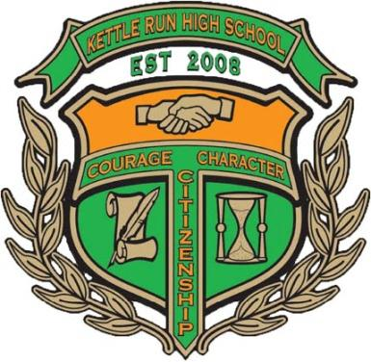

**Please send completed registration form with your check - payable to**

**KRHSBBA -** BEFORE April 1,2015:

Kettle Run H.S. Band

Attn: Rich Searles

Golf Outing Director

4045 Cray Drive

Warrenton, VA 20187

rich.searles@yahoo.com

571-535-6817

* Closest-to-the-pin
* Most-accurate drive
* Speed hole
* Major drive
* CASH prizes for 1st & 2nd place teams
* Door prizes

#### **Prizes and Contests**

#### Raffle tickets will be available for a variety of donated prizes the day of the event.

**Prince William Golf**

14631 Vint Hill Road

Nokesville, VA 20181

**9:00 am Shotgun Start**

Registration 8:00 am

Awards to follow

**All proceeds will benefit the**

**Kettle Run High School Bands**

*$20 of the entry fee is*

*tax deductible*

Tax ID# 26-2383761

**Kettle Run Band**

**5th Annual**

**Golf Outing**

April 17, 2015

Matt Yonkey, Band Director

Kettle Run High School  
Nokesville, VA 20181

kettlerunband.org

Player 1:

________________________

Player 2:

________________________

Player 3:

________________________

Player 4:

________________________

*Individuals welcome.

# Team Registration

Sponsorship Opportunities

* **$ 500 Wind Ensemble Level**
* **$ 300 Symphonic Level**
* **$ 100 Concert Level**
* **We are Friends of Kettle Run Band and would like to make a donation $ __________**

***Sponsorship Registration:***

Player 1: ___________________________

Player 2:

___________________________

Player 3:

___________________________

Player 4:

___________________________

**Golf Sponsorship:**

**$ 500 Wind Ensemble Level:**

*includes a foursome, T-Box sign, an ad on the KRHS website & Band Program*

**$ 300 Symphonic Level:**

*includes a foursome and a*

*T-Box sign*

**$ 100 Concert Level:**

*includes a T-Box sign only*

**How much is it?**

$65 Entry fee per person

**When is it & when does it start?**

Friday, April 17, 2015

Registration: 8:00 a.m.

Shotgun Start: 9:00 a.m.

**What format?**

Captain’s Choice

**What do I/we get for our entry fee?**

* Greens fee & cart
* Range balls
* Beverages to quench your thirst
* Catered lunch

## Q&A