Put on your golfing shoes and step out to enjoy a fun day with your friends and colleagues.
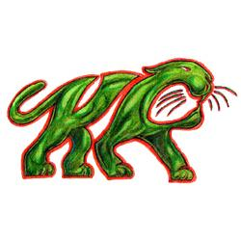
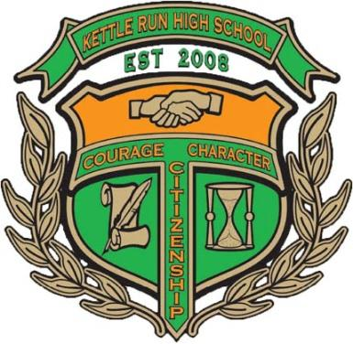
KRHS Band 7th Annual Golf Outing
Location: Prince William Golf Course
14631 Vint Hill Road
Nokesville, VA 20181
http://www.princewilliamgolf.com

Friday, April 21, 2017
Shotgun Start: 9:00 a.m. Registration: 8:00 a.m.
Format: Captain’s Choice
Golf package includes:
- Greens fee & cart | - Range balls
- Beverages to quench your thirst | - Catered lunch

(Same Great Price!) Entry Fee: $65 per person (Same Great Price!)

Prizes & contests for “Closest-to-the-pin”, “Speed Hole”
“Most-accurate drive”, “4 Holes-in-one” chances,
and CASH prizes for 1st & 2nd place teams overall.
Door prizes too!

Sponsorship opportunities:
$ 500 Wind Ensemble Level
Includes a foursome, T-Box sign, an ad
posted on the KRHS website & in the Band Program

$ 300 Symphonic Level
Includes a foursome and a T-Box sign

$ 100 Concert Level
Includes a T-Box sign

“Friends of Kettle Run Level”
Donations in any amount graciously accepted

All proceeds will benefit the Kettle Run High School Bands
$20 of the entry fee is tax deductible
Tax ID# 26-2383761
For more information, Please contact: Rich Searles at Rich.Searles@yahoo.com or (571)-535-6817

