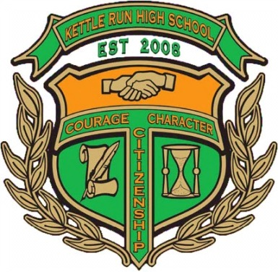

#### Prizes and Contests

#### Raffle Tickets will be available for a variety of donated prizes the day of the event.

* Closest to the pin
* Most accurate drive
* Putting Contest
* CASH prizes for 1st, 2nd, 3rd place teams overall
* 50/50 raffle
* Door prizes

Matt Yonkey,Band Director

Kettle Run High School  
Nokesville, VA 20181

kettlerunbands.org

**Prince William Golf**

14631 Vint Hill Road

Nokesville, VA 20181

**9:00 am Shotgun Start**

Register by 8:00 am

Awards to follow

**Please send completed registration form with your check to:**

**KRHSBBA** and return BEFORE April 1st

Kettle Run H. S. Band

Attn: Mr. Matt Yonkey

Golf Outing Director

7403 Academic Avenue

Nokesville, VA 20181

Player 1: ________________________

(Max 30) Handicap: ________

Player 2:

________________________

(Max 30) Handicap: ________

Player 3:

________________________

(Max 30) Handicap: ________

Player 4:

________________________

(Max 30) Handicap: ________

# Team Registration

**All proceeds will benefit the**

**Kettle Run High School Bands**

*$40 of the entry fee is*

*tax deductible*

**Kettle Run Band**

**4th Annual**

**Golf Outing**

April 25, 2014

## Q & A

Sponsorship Opportunities

* **$ 750 Wind Ensemble Level**
* **$ 500 Symphonic Level**
* **$ 100 Concert Level**
* **We are unable to attend but would like to make a donation $ __________**

***Sponsorship Registration:***

Player 1: ___________________________

(Max 30) Handicap: ___________

Player 2:

___________________________

(Max 30) Handicap: ___________

Player 3:

___________________________

(Max 30) Handicap: ___________

Player 4:

___________________________

(Max 30) Handicap: ___________

**Golf Sponsorship:**

**$ 750 Wind Ensemble Level:**

*includes a foursome*

*T-Box sign*

*an Ad on the KRHS Website & Band program*

**$ 500 Symphonic Level:**

*includes a foursome*

*T-Box sign*

**$ 100 Concert Level:**

*includes a T-Box sign only*

**“I don’t golf” Level:**

*includes signage on cart path*

**Hole-in-one Sponsorship:**

*Available starting at $300*

**Beverage Sponsorship:**

*Contact “outing director” for more details*

**How much is it?**

$85 Entry fee per person

$75 for county employees & our military

**When is it & when does it start?**

Friday, April 25, 2014

Registration: 8:00 a.m.

Shotgun Start: 9:00 a.m.

**What format?**

Captain’s Choice

**What do I / We get for our entry fee?**

* Greens fee & cart
* Range balls
* Beverages to quench your thirst
* Catered cookout