Kettle Run
High School Music Dept.
Final Itinerary
Orlando, FL
April 11 - 16, 2014
Need a QR Code/Scan Reader App?
Go to the app store on your smart phone and download any FREE QR reader.
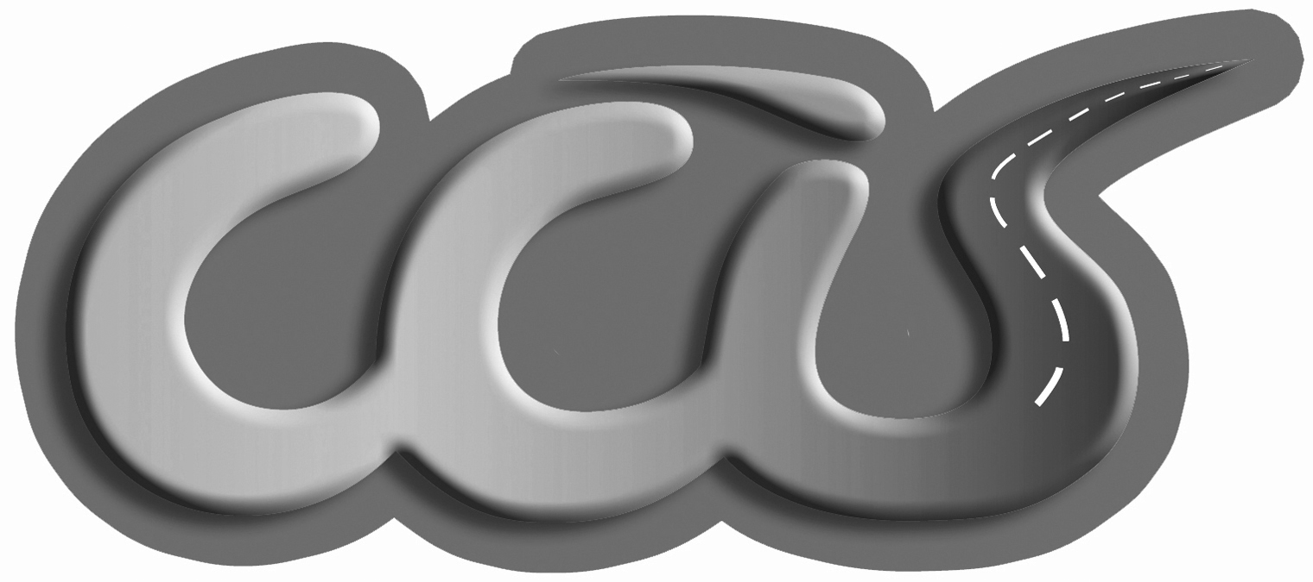
Kettle Run
High School Music Dept.
Final Itinerary
Orlando, FL
April 11 - 16, 2014
Need a QR Code/Scan Reader App?
Go to the app store on your smart phone and download any FREE QR reader.

